[](http://www.google.com/url?sa=i&rct=j&q=&esrc=s&source=images&cd=&cad=rja&uact=8&ved=0ahUKEwiklo_81bzYAhVJ7IMKHaG2AqUQjRwIBw&url=http://canacopegdl.com/synonym/mail.html&psig=AOvVaw1kqSN9rZRmlqqxTAHKjtsM&ust=1515098687302609)

Invoice #20180103__

**2018 ANNUAL MEMBERSHIP FEE**

**BUSINESS NAME: ____________________________**

**___Corporate Sponsorship - $250.00 $________**

**___Gold Sponsorship - $99.00 $________**

**___Website Sponsor - $500.00 (annual fee) $________**

**___Prepaid Breakfast Seminars (8 per year) $________**

NOTE: Corporate/Gold fees do not include breakfast seminars. However, Corporate and Gold sponsorships are entitled to a discounted breakfast fee.

**\*Corporate: $15/pp (Prepaid annual option-$120, regularly $160)**

**\*Gold: $17/pp (Prepaid annual option-$136, regularly $160)**

**Regular/General Member: $20/pp (Prepaid annual option-$160)**

TOTAL AMOUNT DUE…..……………………. $_______

***\*Corporate and Gold Sponsors: Please email your business logo to leigh@cypressbizcomm.com***

Please mail check payable to Northeast FL PCC:

Northeast FL PCC

1100 Kings Road

Jacksonville, FL 32203-9998

or

Pay at <http://www.northeastflpcc.com>

Thank you.

January 3, 2018

[](http://www.northeastflpcc.com/)

**INVOICE**

TAX IDENTIFICATION NUMBER 41-076000

[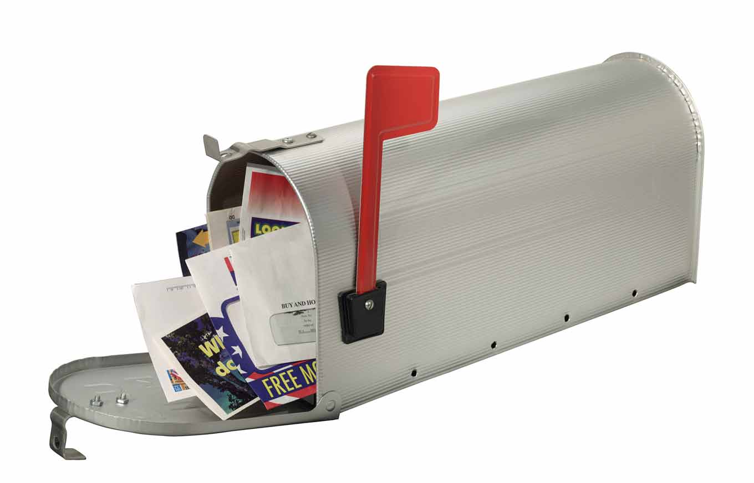](http://www.google.com/url?sa=i&rct=j&q=&esrc=s&source=images&cd=&cad=rja&uact=8&ved=0ahUKEwjzg8_m1LzYAhWM44MKHWAyDT4QjRwIBw&url=http%3A%2F%2Fblog.credit.com%2F2013%2F07%2Fjunk-mail-identity-theft-risks%2F&psig=AOvVaw1kqSN9rZRmlqqxTAHKjtsM&ust=1515098687302609)

MAILING ADDRESS: 1100 KINGS ROAD, JACKSONVILLE, FL 32203-9998 * www.northeastflpcc.com

***PCC Executive***

***Board Members***

**Industry Co-Chair**

Dina Kessler  
*Kessler Creative, Inc.*

*\**

**Postal Co-Chair**

Ken Brantley  
*Officer-In-Charge*

*Jacksonville FL*\*

**Vice Chair**

Chris Huber

*Virtual Systems*

*\****Treasurer**

Bret Freeman   
*TC Delivers*  
*

**Secretary**

Muriel Bremer  
*Konica Minolta*

*

**Other Board Members**

Robert Atkinson  
*VOYA*\*

Dee Carter  
*Customer Relations Coordinator, USPS*

*\**Leigh Gardner

*Cypress Business Communications*

*\**

Ginger Hicks

*Randstad USA*

*\**

Chris Huber

*Virtual Systems*

*\**

Dorsey Hutchinson  
*Xerox*

*\**

Tony Joy

*Manager, Consumer & Industry Contact*

*USPS*

*\**

Dan Lawlor

*Proforma*

*\**

Courtney McGehee  
*Mac Papers*

*\**

Monica O’Connor

*Money Pages*

*\**

Lucious Sumlar

*Marketing Manager, USPS*